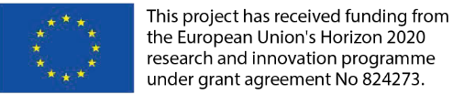
18/06/2021
Author: Bonnie Fenton, Rupprecht Consult
report on gecko stakeholder workshop 3
online, 13-15 april 2021

GOVERNANCE AND NEW MOBILITY: GECKO WORKSHOP 3
Shaping the Future

SUMMARY SHEET
Deliverable No. | 5.3
Project Acronym | GECKO
Full Title | Governance principles and mEthods enabling deCision maKers to manage and regulate the changing mObility systems
Grant Agreement No. | 824273
Responsible Author(s) | Bonnie Fenton, Rupprecht Consult
Responsible Co-Author(s) | -
Peer Review | Yannick Bousse, UITP
Quality Assurance Committee Review | n/a
Date | 2021.06.18
Status | Final
Dissemination level | Public
Abstract | This document reports on the activities of GECKO stakeholder dialogue 3 (13-15.04.21, online).
Version | 1.0
Work package No. | 5
Work package Title | Stakeholder engagement hub and networking
Programme | Horizon 2020
Coordinator | UITP – The International Association of Public Transport
Website | www.h2020-gecko.eu
Starting date | December 2018
Number of months | 33

This report is subject to a disclaimer and copyright. This report has been carried out under a contract awarded by the European Commission, contract number: 824273. The content of this publication is the sole responsibility of the GECKO project.
PROJECT PARTNERS
Organisation | Country | Abbreviation
UNION INTERNATIONALE DES TRANSPORTS PUBLICS | BE | UITP
FIT CONSULTING SRL | IT | FIT
UNIVERSITY COLLEGE LONDON | UK | UCL
POLIS - PROMOTION OF OPERATIONAL LINKS WITH INTEGRATED SERVICES, ASSOCIATION INTERNATIONALE | BE | POLIS
RUPPRECHT CONSULT - FORSCHUNG & BERATUNG GMBH | DE | RC
ABSISKEY | FR | CHT
ABO AKADEMI | FI | ÅA
CONFEDERATION OF ORGANISATIONS IN ROAD TRANSPORT ENFORCEMENT | BE | CORTE
UNIVERSITA COMMERCIALE LUIGI BOCCONI | IT | UB

DOCUMENT HISTORY
Version | Date | Organisation | Main area of changes | Comments
0.1 | 2021.06.18 | Rupprecht Consult | Draft report | -
0.2 |  | UITP | Peer review | -
1.0 |  | Rupprecht Consult | Full report | -

TABLE OF CONTENTs
1. ABOUT GECKO 6
2. OBJECTIVES OF THE STAKEHOLDER ENGAGEMENT PROCESS 7
3. OBJECTIVES OF WORKSHOP 3 8
4. WORKSHOP PARTICIPANTS 9
5. PRE-WORKSHOP QUESTIONNAIRE 10
6. WORKSHOP ACTIVITIES 11
6.1 Conflicting interests (sessions 1 and 2, 13 April) 12
6.2 Looking ahead to 2040 (sessions 3 and 4, 14 April) 18
6.3 Recommendations (session 5, 15 April) 25
6.4 Summary (session 6, 15 April) 30
ANNEX 1: STAKEHOLDER DIALOGUE AGENDA 31
ANNEX 2: WORKSHOP DATES, TIMING AND CONTENT 34
ANNEX 3: WORKSHOP ATTENDEES 36
ANNEX 4: PRE-WORKSHOP QUESTIONNAIRE QUESTIONS 39
ANNEX 5: GECKO 2040 VISION 43

LIST OF FIGURES
Figure 1: Regulatory changes and the challenge that each could imply to the public sector 13
Figure 2: Conflicting interests: group 1 whiteboard results 15
Figure 3: Conflicting interests: group 2 whiteboard results 16
Figure 4: Overview of conflicts identified by stakeholder by topic 17
Figure 5: Development of the GECKO compliance map 18
Figure 6: GECKO regulation monitoring tool: the compliance map 19
Figure 7: Summary of GECKO 2040 vision for urban mobility 20
Figure 8: Looking ahead to 2040: group 1 whiteboard results 21
Figure 9: Looking ahead to 2040: group 2 whiteboard results 22
Figure 10: Looking ahead to 2040: stakeholder comments on the challenges 23
Figure 11: Summary of immediate, mid-term and ongoing challenges and some suggested actions identified by stakeholders 24
Figure 12: Different governance models and their applicability for new mobility services and technologies 25
Figure 13: Regulatory responses to Covid-19 affecting new mobility services and technologies, as identified by the GECKO project 26
Figure 14: Matrix of governance responses to Covid-19 and the impact of the responses on new mobility services and technologies 27
Figure 15: Recommendations session whiteboard results 28
Figure 16: Overview of the outcome of the Recommendations session 29
Figure 17: Overview of summary session 30

List of Tables
Table 1: Overview of workshop sessions 11
Table 2: GECKO project input at stakeholder workshop 3 11
Table 3: Discussion topics and descriptions for the Conflicting Interests session 14

ABOUT GECKO
The rapid proliferation of new technologies and disruptive innovations are taking the world by storm, threatening well established players across many sectors. Regulators and decision-makers at different levels of government are overwhelmed by the challenge, acknowledging that existing frameworks may be inadequate in terms of protecting society, fostering business development and achieving integrated, sustainable mobility.
GECKO’s main goal is to support authorities with tools and recommendations for new regulatory frameworks to lead the transition to the new mobility era of cooperative, inclusive, competitive, sustainable and interconnected mobility across all modes, through evidence-based research.
GECKO provides a holistic approach with innovative concepts, methodologies and forward-looking tools to enable this transition to take place, leading to new, adaptive and anticipatory regulatory schemes and balanced governance.
The project aims to build on the strong networks of its partners to ensure solutions are co-designed and validated. A number of key indicators and cooperation models will help to develop the Regulatory Frameworks Dashboard, though which the maturity of given regulations can be judged with respect to emerging mobility solutions.
GECKO will outline an implementation plan including actions required up to 2040 for policy makers to devise regulatory approaches for disruptive innovations and new regulatory frameworks streamlining uptake. GECKO will advise policy makers on challenges and policies that need to be addressed to move towards integrated, accessible and sustainable mobility across modes for both passenger and freight transport.
The project will provide recommendations to policy makers to enable adaptive and anticipatory regulatory schemes and governance with novel policies that contribute to sustainable mobility goals.

OBJECTIVES OF THE STAKEHOLDER ENGAGEMENT PROCESS
The objectives of the stakeholder engagement work package, WP5, are to:
- start up and stimulate debate on impacts of business and operating models on regulatory schemes at EU28 and International (Japan, US, Singapore and China) debate among relevant stakeholders (WP2)
- establish and manage a bottom-up consultation process, organise and facilitate effective and meaningful conversations at multi-stakeholder level in 3 thematic working groups on automation and emerging technologies; shared mobility/public transport/Mobility as a Service and digitalisation and data-driven models;
- get input on experience, lessons and practices on technological, social, economic, political drivers and barriers affecting the forthcoming deployment of innovative business models and technologies (WP1 and 2);
- report strategic outlook to set up policy recommendations and roadmap on joint and co-actions addressing societal, economic and political aspects both EU and global strategic agenda and device new regulatory framework and governance in innovative mobility (WP4)
Through WP5, GECKO organises, conducts and analyses the results of an intensive stakeholder engagement process to ensure that the vision, views, challenges, constraints, expectations and ideas of stakeholders are understood and can inform not only future regulations but – more importantly – the foundational principles of future regulation making processes.
One of the key principles in the stakeholder process is an open give and take among all participants. Stakeholders understand that their on-the-ground experience and their expertise are valuable to the GECKO project. Likewise, the project is able to a) bring new insights to stakeholders through its research, data collection and analysis and b) connect stakeholders with one another so that they can also better understand the needs of actors in other areas of new mobility.

OBJECTIVES OF WORKSHOP 3
Directly relate to the work currently being done by the project partnership, Workshop 3 was focussed specifically on obtaining input from new mobility stakeholders on:
- What new governance models could or should look like
- Understanding the regulation-related barriers to achieving a sustainable mobility future, looking at timeline up to 2040
- The role of the European Commission and decision makers at other levels with regard to changes in governance structures and regulatory frameworks to facilitate positive change in mobility while discouraging change that doesn’t lead to a sustainable and equitable future
Some of this input was gathered through a pre-workshop questionnaire. The results were shared with participating stakeholders via on online whiteboards and served as a basis for the discussions in the sessions on looking ahead to 2040 and the recommendations sessions.

WORKSHOP PARTICIPANTS
The aim was to have roughly 30 stakeholders attend each of the three planned workshops throughout the lifetime of GECKO.
A representative group of 15 “core” stakeholders was selected at the outset to attend all three workshops. This was intended to provide a certain continuity across all workshops. This group represents the geographic areas of Europe (Northwest Europe, Central Europe/ Baltic states, Eastern Europe/ Balkan states, Southern Europe/ Mediterranean, Nordic countries) and beyond, and all three sectors of stakeholder (public – at all levels of government, private – in a range of industries, and other influencers) with a stake in the fields being examined by the project: 1) automation and emerging technologies; 2) shared mobility, public transport and Mobility as a Service and 3) digitalisation and data-driven models. A gender balance was also achieved.
The other 15 invitees were part of the “flex” group, i.e., 15 different people will be invited to each workshop. This was done so as to combine continuity with fresh perspectives at each workshop and to allow us to focus invitations on particular topics areas, backgrounds or mobility areas as dictated by the stakeholder input needed at the given stage of the project.
As with stakeholder Workshop 2, Workshop 3, was held online due to the ongoing pandemic. Selected stakeholders were invited to one or more in a series of online focus group discussions. Taking advantage of the removal of the barrier of travel costs, a larger circle of attendees was invited to individual sessions based on their interest and expertise. Using the online format, we were able to include 39 stakeholders (plus consortium members) in the various online sessions.
See ANNEX 3: WORKSHOP ATTENDEES for a complete list of workshop attendees.

PRE-WORKSHOP QUESTIONNAIRE
A pre-workshop online questionnaire was sent out to all GECKO stakeholders several weeks in advance of the workshop. The questions were designed to gather stakeholder input which is difficult to come by otherwise and to feed and complement the discussions planned for the workshop itself.
The pre-workshop questions were developed by a group of project partners with the specific goal of gathering input needed input for the project at its current stage. The specific areas of interest in this survey were positions and policy statements around the regulation and governance of new mobility, prioritisation of the challenges to regulating new mobility and Covid-19 and the governance of new mobility. Responses to the Covid-related questions fed into an academic paper being written by some project partners on this topic.
50 surveys were submitted, of which 43 were complete and valid. See ANNEX 4: PRE-WORKSHOP QUESTIONNAIRE QUESTIONS for the complete list of questions.

WORKSHOP ACTIVITIES
The format and activities of the stakeholder dialogue were developed for an online format. Activities were spread over three days and focussed invitations were made to individuals to specific 60 or 90-minute sessions based on their interests and expertise. A total of six sessions were held:
- A session on between the public and the private sector and how these can be overcome (offered twice to allow for both Asian and North American participation)
- A session on looking ahead to 2040 and the steps needed to reach the envisioned scenario (offered twice to allow for both Asian and North American participation)
- A recommendations session
- A plenary at the end in which the outcomes of the other sessions were shared with all
See an overview of all sessions in Table 1.
Table 1: Overview of workshop sessions
Tuesday, 13.04.2021 | 10:00-11:30 CEST | Conflicting interests, session 1
Tuesday, 13.04.2021 | 15:30-17:00 CEST | Conflicting interests, session 2
Wednesday, 14.04.2021 | 10:00-11:30 CEST | Looking ahead to 2040, session 1
Wednesday, 14.04.2021 | 15:30-17:00 CEST | Looking ahead to 2040, session 2
Thursday, 15.04.2021 | 10:00-11:30 CEST | Recommendations
Thursday, 15.04.2021 | 16:00-17:00 CEST | Summary

Activities were planned to provide a balance of “give” and “take” with the stakeholders, covering the topic areas as described under OBJECTIVES OF WORKSHOP 3. In this online format, the “giving” portions of the workshop took place through GECKO project presentations in each of the sessions. See Table 2:
Table 2: GECKO project input at stakeholder workshop 3
Session | GECKO input
Conflicting interests | Overview of new mobility services and business models (D1.4)
Looking ahead to 2040 | GECKO new mobility regulation map (D3.3)
Recommendations | Analysis of regulations and governance models (D2.4)
Wrap-up | The session was made up of sharing input from the rest of the week’s sessions

In exchange, the project requested of participants:
- completion of the pre-workshop questionnaire to provide input to project data needs
- active participation in one or more workshop sessions (with related online whiteboard)

6.1 Conflicting interests (sessions 1 and 2, 13 April)

GECKO input
Sessions 1 and 2 looked at conflicting (and also converging) interests between the public and the private sectors. Each of the two sessions began with project input. This included new mobility services and technologies reviewed by GECKO, business models for different new mobility services and technologies and a series of changes in regulations or governance structures and the challenges these can present for private sector providers of new mobility services or technologies (see Figure 1).

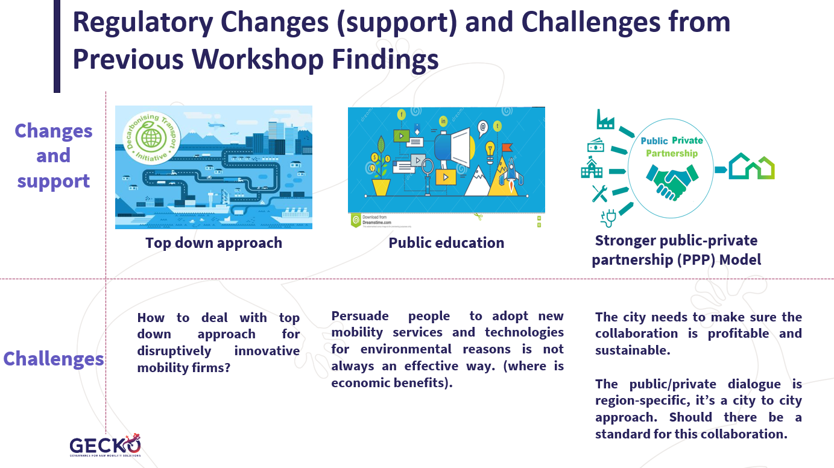
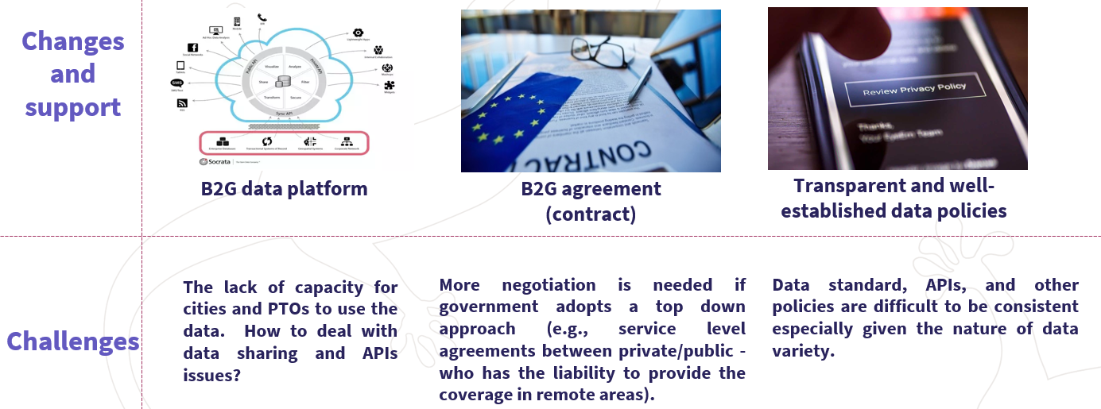
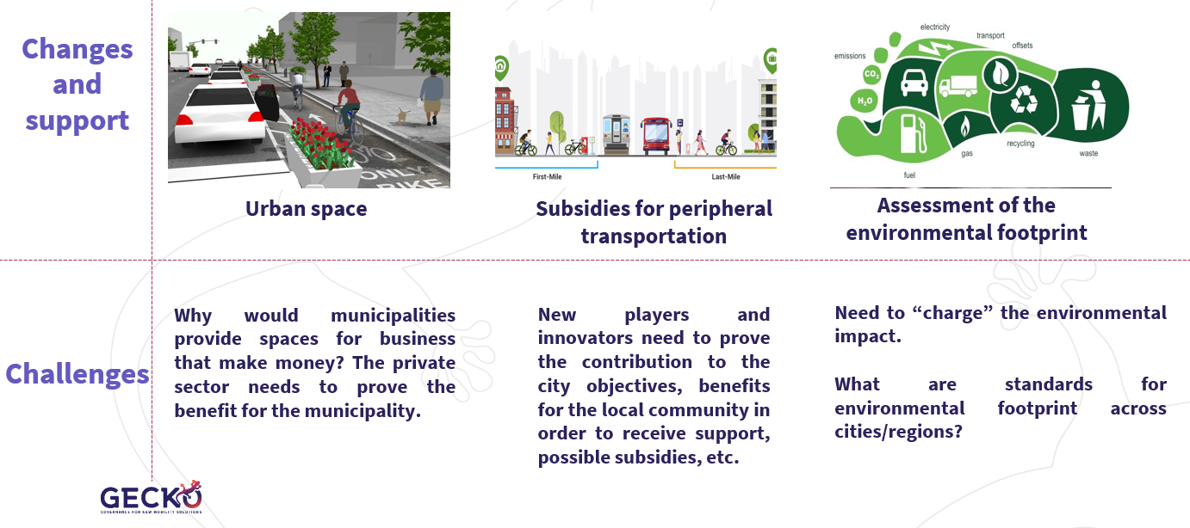
Figure 1: Regulatory changes and the challenge that each could imply to the public sector

Stakeholder input
Two conflicting interest sessions were held. The same format and white board template were used for both sessions. The two sessions allowed us to invite more stakeholders and to allow participation from both Asia and North America. The questions were developed in collaboration with, and the topic was introduced by, GECKO colleagues from Polis, who are responsible for the deliverable Guidance for New Governance Models. Invited stakeholders represented the public and the private sectors as these are the sectors where conflicting interests have been identified throughout the project.
The topic was divided into four sections to allow for more focussed discussion. See Table 3.
Table 3: Discussion topics and descriptions for the Conflicting Interests session
Transport justice and social inclusion | Away from the city centre, many suburbanites are either locked into car-dependency (and highly sensitive to restrictions), or captive users of public transport (who dream of buying a car). Accelerating the shift to sustainable mobility requires providing these populations with affordable options.
Fair labour practices | Some new mobility services, created by highly qualified tech professionals, with generous pay and benefits, are generating thousands of low-pay, no-benefit, “individual entrepreneurs”. The externalisation of labour costs provides a competitive advantage – but who deals with the side-effects?
Protecting and serving the backbone (public transport) | Mass Public Transport carries large numbers of passengers, has deep influence in land-use, and (as became evident throughout the pandemic) is what keeps running, when crisis comes. It is the backbone of the urban mobility system – but it has its limitations, regarding capillarity and off-peak periods.
Encourage active mobility | Walking is the most environment-friendly mode of transport, with cycling a close second. We need to reduce transport carbon emissions, but in our sedentary society we also need more active mobility, to improve physical and mental health.

Each topic offered space to provide input and views on:
- Converging interests between public and the private sector interests
- Conflicting interests between public and the private sector interests
- Advice for those developing the new governance models
Stakeholder feedback was captured on an online white board (one for each group) (see Figure 2 and Figure 3). The main points were then summarised to be shared with group in workshop session 6 (see Figure 4).

- 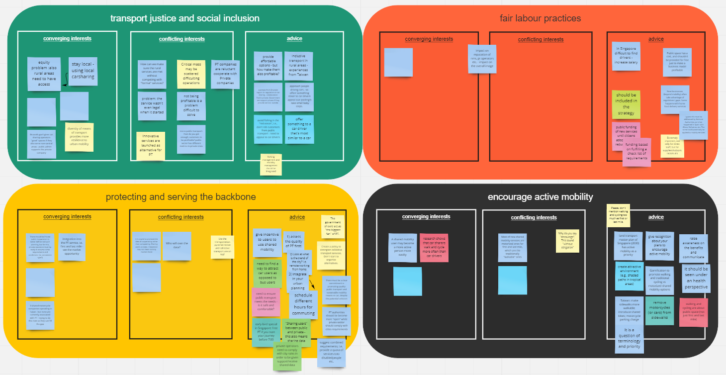
Figure 2: Conflicting interests: group 1 whiteboard results
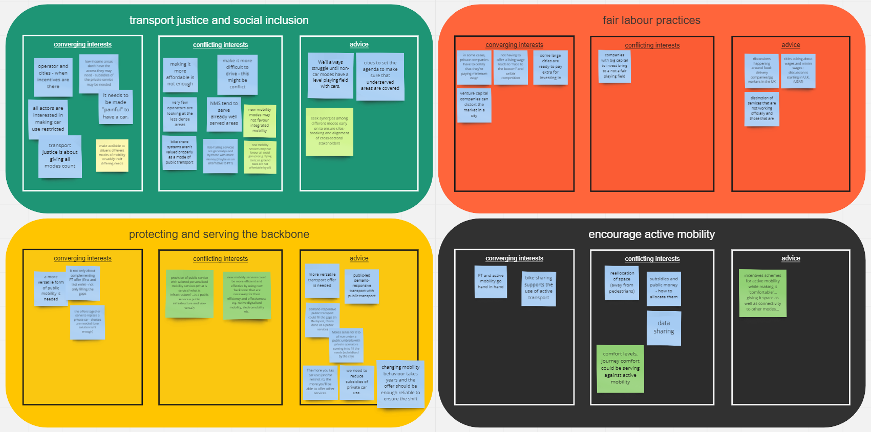
Figure 3: Conflicting interests: group 2 whiteboard results
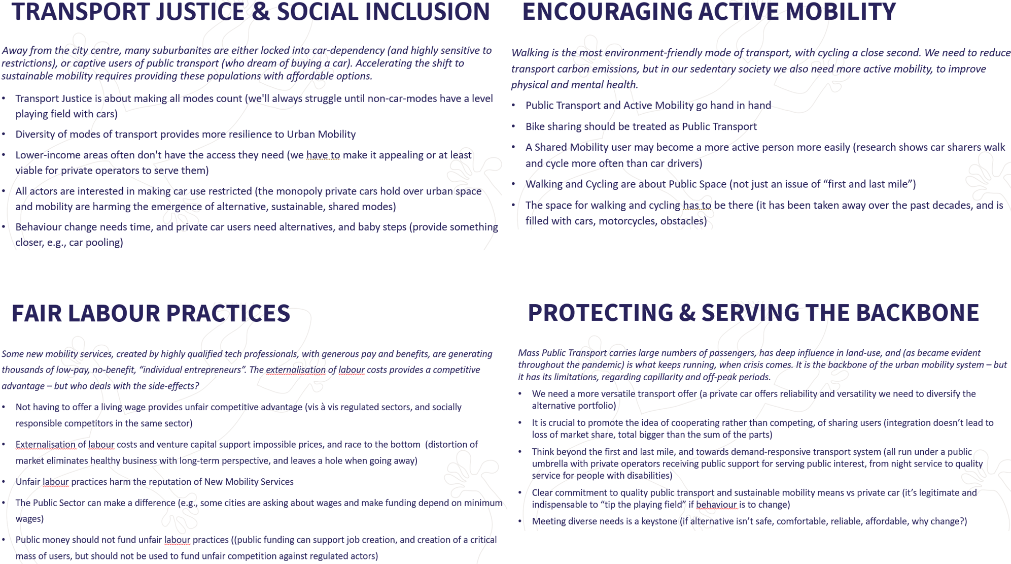
Figure 4: Overview of conflicts identified by stakeholder by topic

6.2 Looking ahead to 2040 (sessions 3 and 4, 14 April)

GECKO input
The session started with GECKO input on the compliance map developed in the GECKO project. The objective of the GECKO compliance map is to assess the capability of existing regulatory frameworks to enable the implementation of innovative technologies and business models, while still safeguarding adequate level of security, safety, data privacy, and social protection. We looked at how the compliance map was developed and the performance indicators that were included to evaluate each of the regulations included in the monitoring tool (see Figure 5).
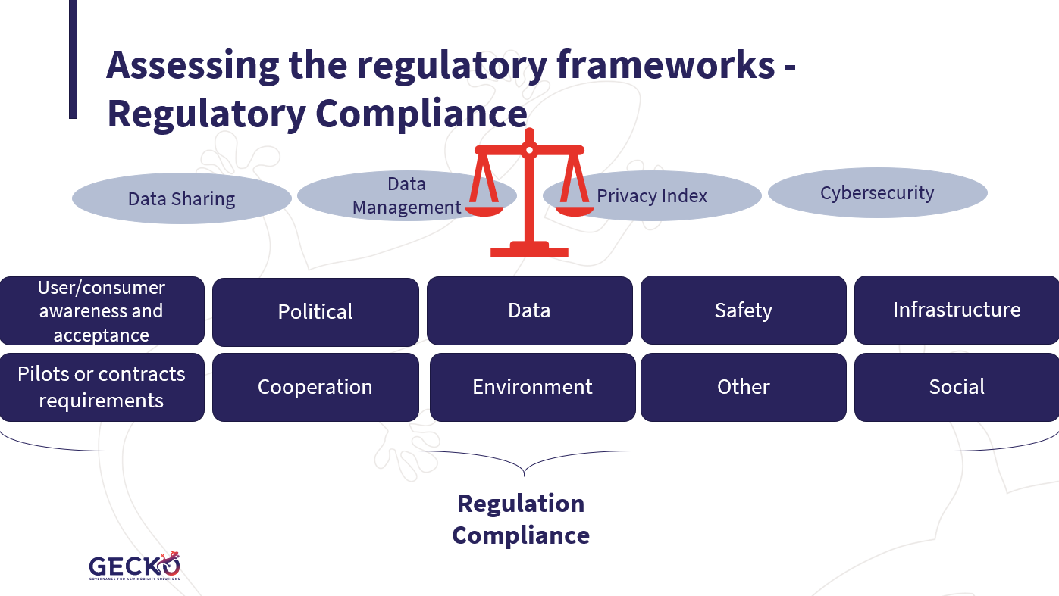
Figure 5: Development of the GECKO compliance map
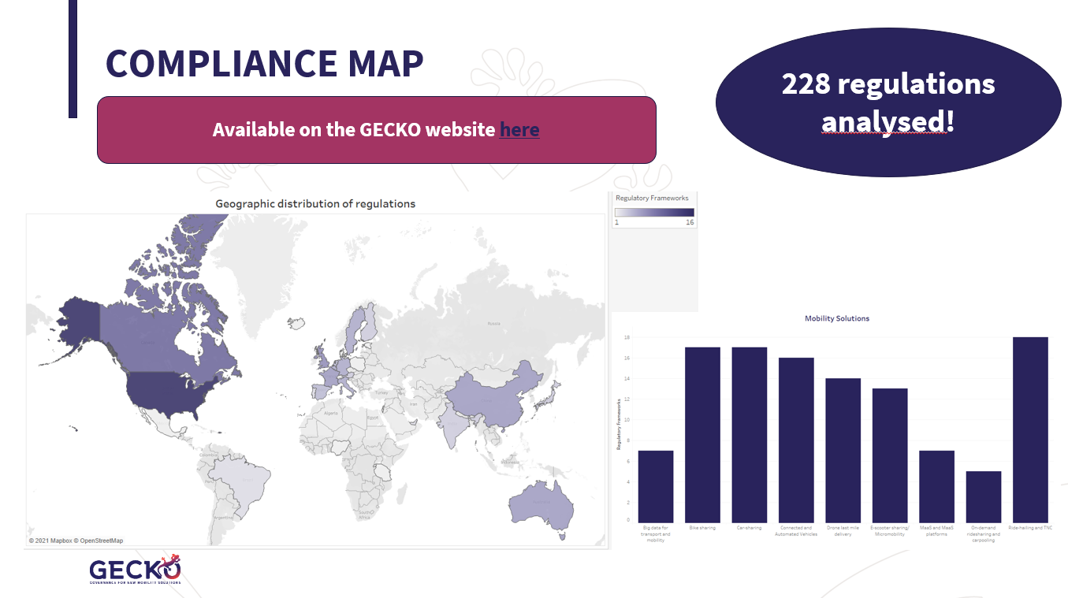
Figure 6: GECKO regulation monitoring tool: the compliance map

The GECKO compliance map tool is available on the GECKO website at: Compliance Map: GECKO (h2020-gecko.eu).

Stakeholder input
In preparation for the session “Looking ahead to 2040”, stakeholders were asked to complete pre-workshop survey questions asking them to prioritise a range of challenges around the regulation of new mobility (see Figure 7 and ANNEX 4: PRE-WORKSHOP QUESTIONNAIRE QUESTIONS). The challenges listed in the survey for prioritisation were previously identified by project partners through a review of the project deliverables and products and stakeholder input to date.
In advance of the workshop, participating stakeholders were also provided with GECKO’s sustainable mobility vision for 2040 (see ANNEX 5: GECKO 2040 VISION).

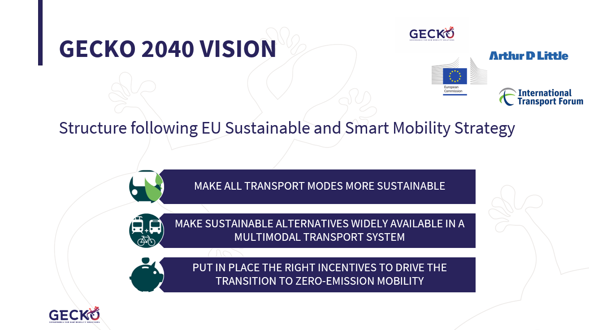
Figure 7: Summary of GECKO 2040 vision for urban mobility

The results of the pre-workshop survey provided the content that served as the basis for the white board used for these two sessions. In the survey, stakeholders were asked to prioritise challenges to the implementation of new mobility technologies and services as “must be addressed immediately”, “should be addressed in the medium term”, “not a priority” and “an ongoing tension that we’ll have to live with”. There were some significant differences in views among the different stakeholder groups about the priorities.
In the first session (see Figure 9), the stakeholders focussed on establishing a shared prioritisation of the challenges that were identified. Many comments and discussion points helped to focus and sharpen the identified challenges. There was quite a bit of discussion about what was defined as an “ongoing tension that we’ll have to live with”. Through the discussion, the stakeholders came to the agreement that this category was inappropriately named; the group decided it was rather “issues that need to be addressed on an ongoing basis”. The main comments can be found in Figure 11.
In the second session (see Figure 10), the stakeholders focussed on identifying actions to address the challenges identified as top and medium priorities. The identified immediate and mid-term priorities and ongoing issues – together with suggested actions – are summarised in Figure 13.

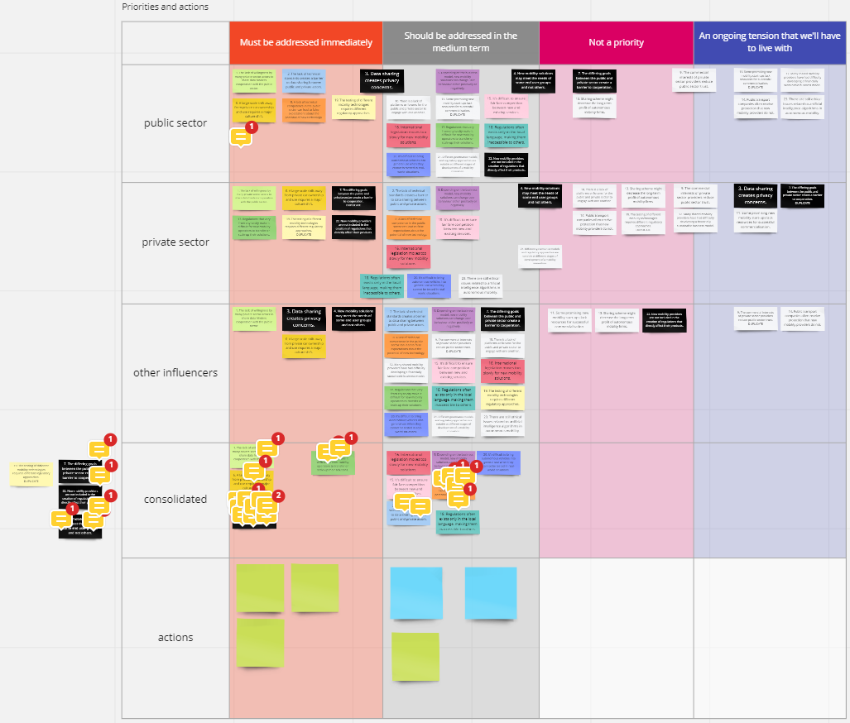
Figure 8: Looking ahead to 2040: group 1 whiteboard results

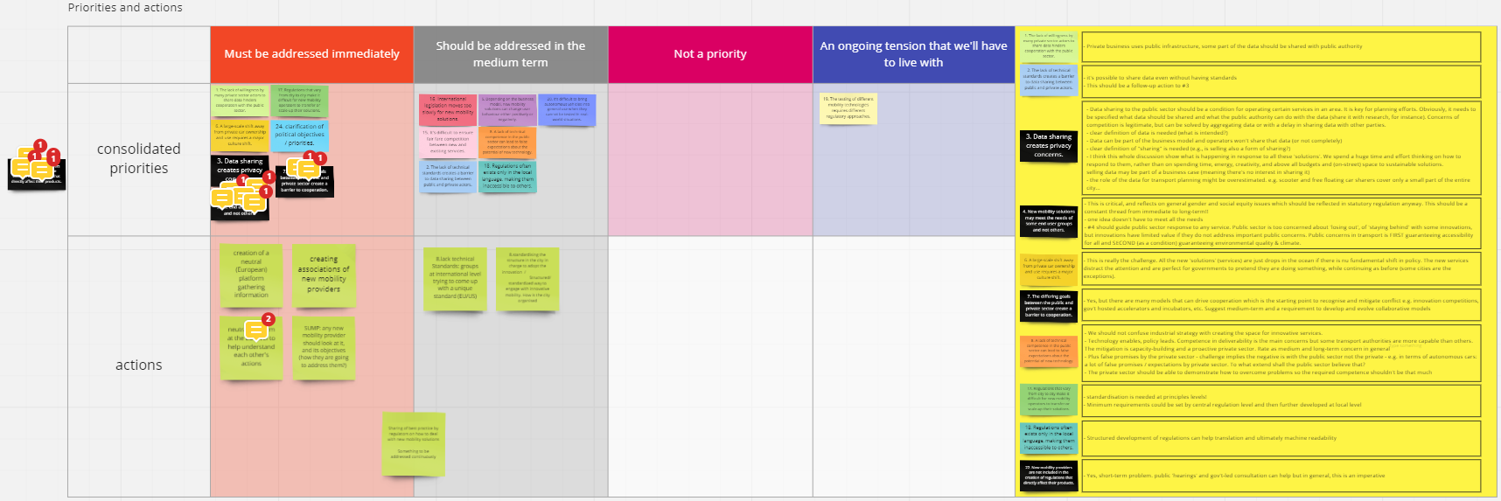
Figure 9: Looking ahead to 2040: group 2 whiteboard results

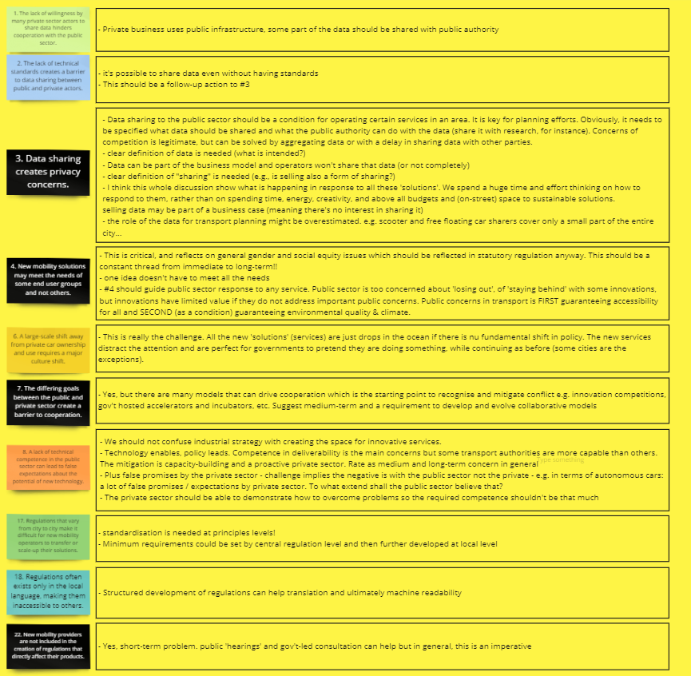
Figure 10: Looking ahead to 2040: stakeholder comments on the challenges

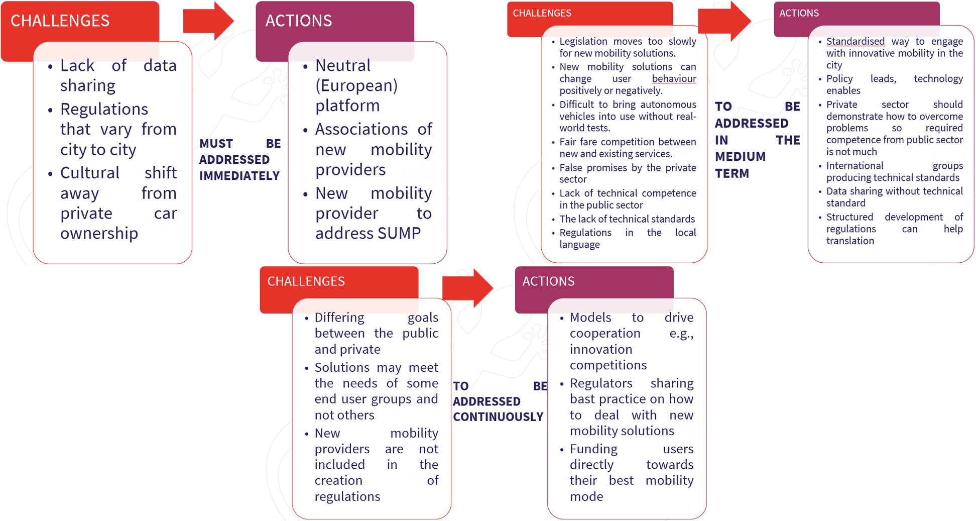
Figure 11: Summary of immediate, mid-term and ongoing challenges and some suggested actions identified by stakeholders

6.3 Recommendations (session 5, 15 April)

GECKO input
In this session, stakeholders were provided with:
- an overview of governance models and regulatory responses for mobility innovations
- the highlights of a research paper written by GECKO partners looking at the regulatory responses to Covid-19 that affect new mobility services and technologies.
The report on the current governance of mobility innovations looked at the government level at which regulations are set as well as the approaches to governance. The applicability of different governance models is summarised in Figure 12. An example of Mobility as a Service was provided, showing examples of regulatory aspects taking place at the EU, national and local levels.

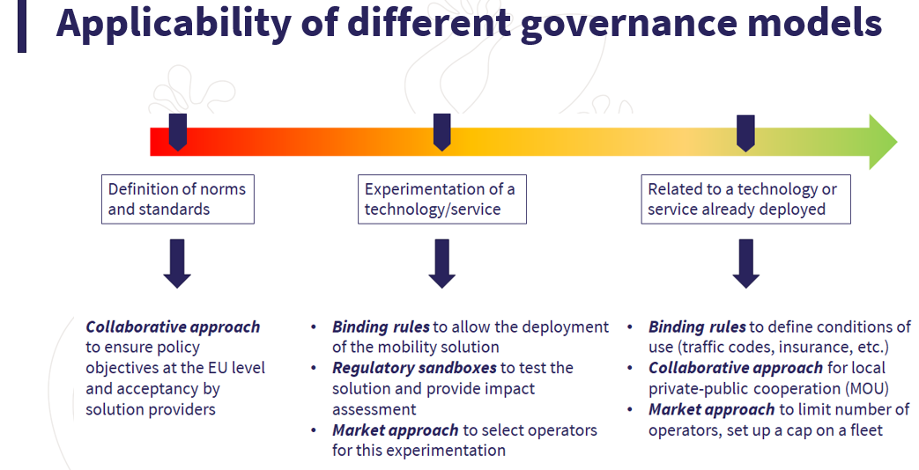
Figure 12: Different governance models and their applicability for new mobility services and technologies

The research paper described some Covid-19-related regulatory changes that have affected new mobility. These include free parking in some city centres, financial support for shared bicycles, temporary bike lanes and collaboration for traffic monitoring between private and public parties (see Figure 13).

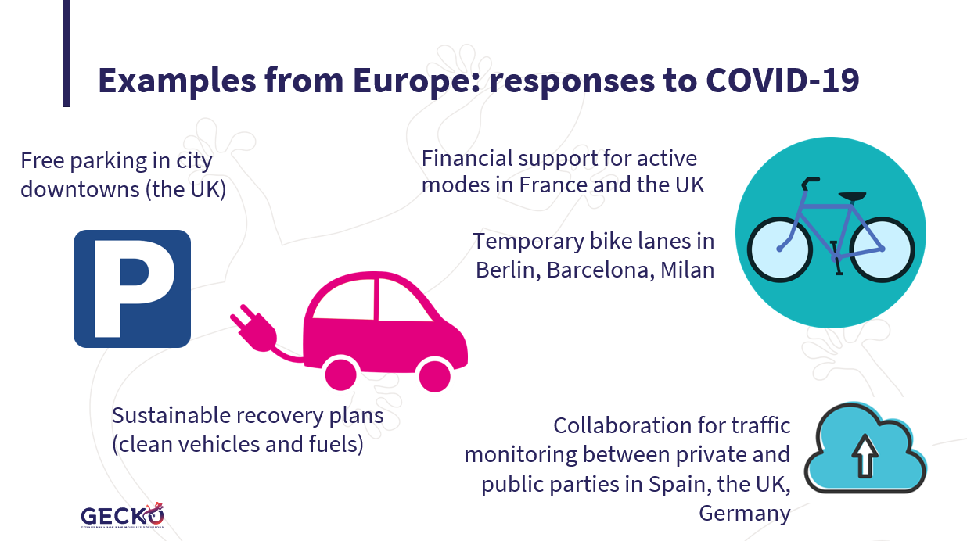
Figure 13: Regulatory responses to Covid-19 affecting new mobility services and technologies, as identified by the GECKO project

The outcome of the research paper looking at the regulatory responses to Covid-19 indicated some long-term impacts on the governance of mobility innovations. These include:
- Rethinking the role of public transport vs mobility services
- Changes in city space planning
- Collaborative governance
- Adaptive, flexible governance
- Data-driven governance
See also Figure 14.
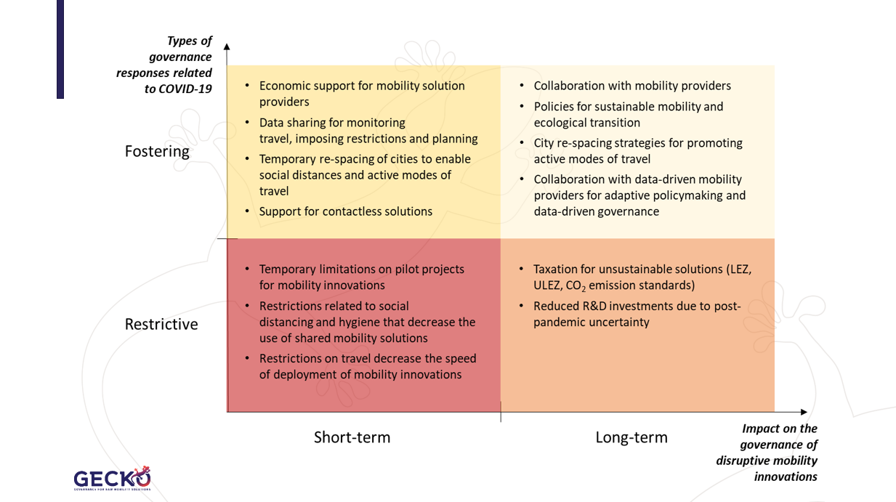
Figure 14: Matrix of governance responses to Covid-19 and the impact of the responses on new mobility services and technologies

Stakeholder input
In the pre-workshop stakeholder survey, a set of policy statements was provided to the stakeholders, who were asked to express their level of agreement with each one. The statements had been identified by project partners through an analysis of project documentation.
Eleven policy statements were extracted from the output of the stakeholder survey, and these were categorised for the workshop whiteboard into the following groups (see also Figure 15):
- Private-public collaboration
- Data
- New regulatory approaches
- Sustainability, society and safety
For each of the identified policy statements, stakeholders were asked to consider the three questions:
- What’s preventing us from getting there?
- Who is responsible for making this a reality?
- What is the role of the European Commission?
The discussion results are summarised in Figure 16.

- 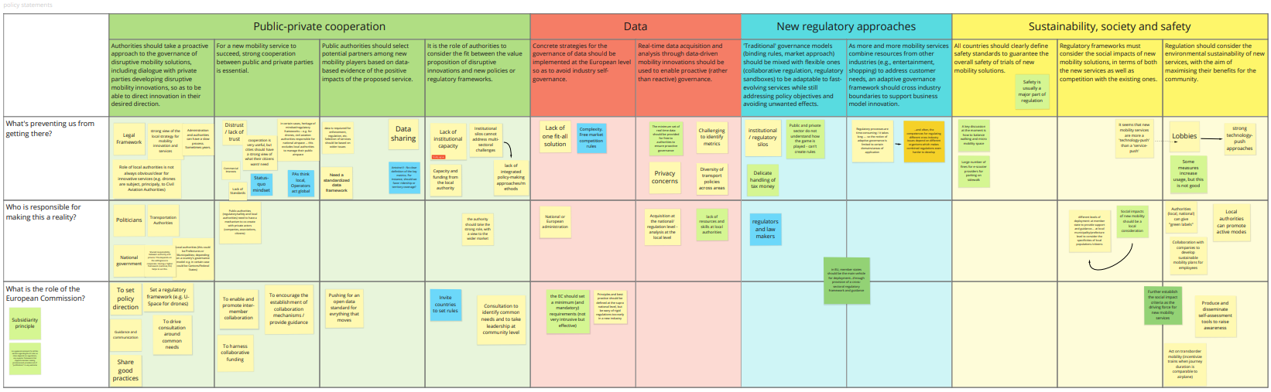
Figure 15: Recommendations session whiteboard results

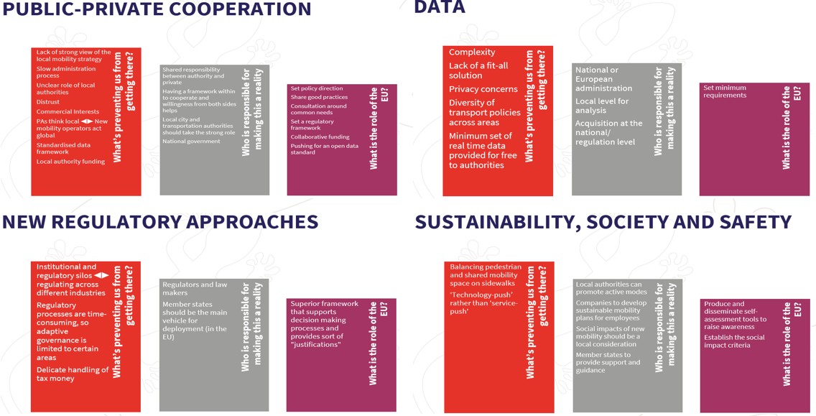
Figure 16: Overview of the outcome of the Recommendations session

6.4 Summary (session 6, 15 April)

GECKO input
The final session summarised all the previous sessions for the stakeholders so that they could learn from the sessions they were not involved in (see Figure 16).
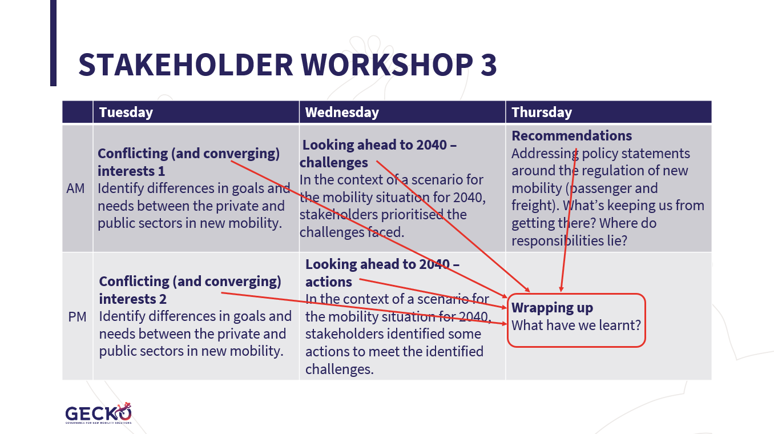
Figure 17: Overview of summary session
A summary of the points discussed in the sessions on conflicting (and converging) interests between the public and private sector (see 6.1 Conflicting interests (sessions 1 and 2, 13 April)) was provided. The main points are listed in Figure 4. This input fed directly into deliverable 4.1, Guidelines for new governance models.
A summary of the points discussed in the sessions on looking ahead to 2040 (see 6.2 Looking ahead to 2040 (session 3 and 4, 14 April)) was provided. The main points are listed in Figure 12. This input fed directly into deliverable 4.2, Adaptive Roadmap 2040.
A summary of the points discussed in the Recommendations sessions (see 6.3 Recommendations (session 5, 15 April)) was provided. The main points are listed in Figure 14. This input fed directly into deliverable 4.3, Joint Position Paper.

All Workshop 3 presentation slides, as well as the video recordings of the workshop sessions can be found on the GECKO website at: Presentations: GECKO (h2020-gecko.eu).

ANNEX 1: STAKEHOLDER DIALOGUE AGENDA
GOVERNANCE and NEW mobility: GECKO workshop 3 SHAPING THE FUTURE
agenda
13-15 April 2021 (online)

Note, stakeholders will be invited to individual sessions (as opposed to the entire week) and all will be invited to the final (summary) session on Thursday afternoon.
Tuesday, 13 April
10:00-11:30 | Conflicting interests – session 1  (6 stakeholders each from the private and the public sector)  This session will take the form of group discussions. We’ll ask participants to identify and address some of the differences in goals and needs between the private and public sectors in new mobility.  - What are the conflicting interests?  - How can these be overcome?  GECKO input: overview of new mobility services and business models | - Pedro Homem de Gouveia, Pasquale Cancellara and Piero Valmassoi, Polis  - Bonnie Fenton, Rupprecht Consult
15:30-17:00 | Conflicting interests – session 2  (6 stakeholders each from the private and the public sector)  This session will take the form of group discussions. We’ll ask participants to identify and address some of the differences in goals and needs between the private and public sectors in new mobility.  - What are the conflicting interests?  - How can these be overcome?  GECKO input: overview of new mobility services and business models | - Pedro Homem de Gouveia, Pasquale Cancellara and Piero Valmassoi, Polis  - Bonnie Fenton, Rupprecht Consult
Wednesday, 14 April
10:00-11:30 | Looking ahead to 2040 – session 1  (4 stakeholders each from the private and public sector and from “other influencers”)  In the context of a scenario for the mobility situation for 2040 (which we will provide in advance), stakeholders will discuss the steps needed to get there, the challenges faced and how to overcome them.  GECKO input: GECKO new mobility regulation map | - Yannick Bousse, UITP  - Bonnie Fenton, Rupprecht Consult
15:30-17:00 | Looking ahead to 2040 – session 2  (4 stakeholders each from the private and public sector and from “other influencers”)  In the context of a scenario for the mobility situation for 2040 (which we will provide in advance), stakeholders will discuss the steps needed to get there, the challenges faced and how to overcome them.  GECKO input: GECKO new mobility regulation map | - Yannick Bousse, UITP  - Bonnie Fenton, Rupprecht Consult
Thursday, 15 April
10:00-11:30 | Recommendations  (4 stakeholders each from the private and public sector and from “other influencers”)  In this session, we’ll address policy statements around the regulation of new mobility (passenger and freight)  - What needs to be considered?  - What are top priorities?  GECKO input: Analysis of regulations and governance models | - Yannick Bousse, UITP  - Bonnie Fenton, Rupprecht Consult
16 :00-17 :00 | Wrapping up  (open to all GECKO stakeholders)  This final session will be in a webinar format. It’s open to all attendees from the week. Here, we’ll share with you the outcomes of the various sessions from the week. | - Bonnie Fenton, Rupprecht Consult  - Yannick Bousse, UITP  - Pedro Homem de Gouveia, Polis

ANNEX 2: WORKSHOP DATES, TIMING AND CONTENT
 | Workshop 1 | Workshop 2 |  | Workshop 3 | Final conference
Dates | Oct 2019 (M11) | May 2020 (M18) |  | April 2021 (M29) | August 2021 (M33)
Related event | Project consortium meeting | The planned related event, the International Transport Forum did not take place. Instead, the stakeholder dialogue took place online.  The GECKO mid-term stakeholder event, also planned for ITF, has been postponed. Due to Covid uncertainties, a new date has yet to be set. |  | None: free-standing online event
Location | London | online |  | online | online
Project information and knowledge for stakeholders | D1.1 New mobility services and technologies, knowledge bank (M6)  D2.1 Regulatory responses and governance models (M6) | D1.2 Business models for new mobility services (M10)  D1.3 End users’ perspectives and mobility needs (M12)  D2.2 Main economic, political and social variables (M12)  D2.3 Cooperation models among public and private parties (M12)  D2.4 Regulatory approaches and governance models for disruptive innovation (M15)  D3.1 GECKO frameworks dashboard (M14) |  | D1.4 New mobility services and business models (M26)  D2.5 Regulatory responses and governance models (M26)  D3.2 GECKO impact assessment (M20)  D3.3 GECKO compliance map and future requirements (M24) | D4.1 Guidelines for new governance models (M30)  D4.2 Adaptive Roadmap 2040 (M30)  D4.3 Joint Position Paper (M30)
Input requested of stakeholders | D1.2 Business models for new mobility services (M10)  D2.2 Main economic, political and social variables (M12)  D2.3 Cooperation models among public and private parties (M12)  D2.4 Regulatory approaches and governance models for disruptive innovation (M15)  D3.1 GECKO frameworks dashboard (M14) |  | D3.2 Impact assessment (M20)  D3.3 GECKO compliance map and future requirements (M24) | D4.1 Guidelines for new governance models (M30)  D4.2 Adaptive Roadmap 2040 (M30)  D4.3 Joint Position Paper (M30)

ANNEX 3: WORKSHOP ATTENDEES
 | GECKO stakeholder workshop attendees, 13-15 April 2021, online
 | Name |  | Organisation | Session(s)
1 | Vassilis | Agouridas | AIRBUS | Conflicting interests, recommendations, summary
2 | Christophe | Arnaud | Blue Systems | Conflicting interests, recommendations, summary
3 | Giles | Bailey | TravelSpirit Foundation | Looking to 2040, recommendations
4 | Juan Vincen | Balaguer | Zeleros | Conflicting interests
5 | Tommaso | Bonino | SRM Bologna | Recommendations, summary
6 | Yannick | Bousse | UITP (GECKO consortium)
7 | Caroline | Busquet | Absiskey (GECKO consortium)
8 | Pasquale | Cancellara | Polis (GECKO consortium)
9 | Daniele | Celere | Havi Logistics | Looking to 2040, summary
10 | Lewis | Chen | Car Club | Conflicting interests, recommendations, summary
11 | Gennaro | Cicarelli | TTS Italia | Summary
12 | Filip | Djupsjöbacka | Kyyti | Summary
13 | Domokos | Esztergar-Kis | BME Budapest | Summary
14 | Bonnie | Fenton | Rupprecht Consult (GECKO consortium)
15 | Sergio | Fernandez Balaguer | EMT Madrid | Conflicting interests, recommendations, summary
16 | Maciej | Florczak | ZTM Warsaw | Looking to 2040
17 | Nicolas | Frasie | Communauto | Conflicting interests
18 | Marco | Fuster | BERNMobil | Recommendations, summary
19 | Marion | Galan Alonso | Donkey Republic | Looking to 2040
20 | Thomas | Geier | EMTA | Looking to 2040, summary
21 | Michael | Glotz-Richter | City of Bremen | Looking to 2040
22 | Tamás | Halmos | BKK Centre for Budapest Transport | Conflicting interests, summary
23 | Gayang | Ho | UITP Asia Pacific | Looking to 2040
24 | Marc | Iglesias Perez | AMB | Conflicting interests
25 | Ping-Jen | Kao | University College London (GECKO consortium)
26 | Ignat | Kulkov | Åbo Akademi University (GECKO consortium)
27 | Renata | Lajas | ARUP | Looking to 2040, summary
28 | Jeff | Liu | MoT Taiwan | Conflicting interests
29 | Valerio | Lubello | Bocconi University (GECKO consortium)
30 | Pedro | Machado | City of Lisbon | Looking to 2040, summary
31 | Karel | Martens | Technion University Israel | Looking to 2040
32 | Marisa | Meta | FIT Consulting (GECKO consortium)
33 | Angelo | Meuleman | Taxistop | Conflicting interests, summary
34 | Welmoed | Neijmeijer | Bolt | Looking to 2040, summary
35 | Alan | O'Kelly | FREE NOW group | Conflicting interests, summary
36 | Gregor | Petri | Fluidtime Data Services GmbH | Conflicting interests, summary
37 | Andrew | Pickford | TTC Global | Looking to 2040, recommendations, summary
38 | Martin | Röhrleef | UESTRA Hannover | Conflicting interests, summary
39 | Jayant | Sangwan | Corte (GECKO consortium)
40 | Carol | Schweiger | Tech4Transit | Looking to 2040, recommendations, summary
42 | Krysia | Solheim | Nextbike | Conflicting interests, summary
43 | Jakob | Spranger | Toyota Motors Europe | Looking to 2040
44 | Peter | Staelens | Eurocities | Looking to 2040, recommendations, summary
45 | Bronwen | Thornton | Walk 21 | Looking to 2040, summary
46 | Anastasia | Tsvetkova | Åbo Akademi University (GECKO consortium)
47 | Antoine | Verhulst | Blabla Car | Recommendations
48 | Egon | Warkinton | Continental Corporation | Looking to 2040, summary
49 | Claire | Wiseman | Transport for London | Summary

ANNEX 4: PRE-WORKSHOP QUESTIONNAIRE QUESTIONS
About you
- Your name
- Your organisation
- Are you:
  - a public policy maker
  - someone from the private sector who creates or offers new mobility services or technologies
  - a researcher, NGO representative or other with a (non-business) interest in new mobility technologies, issues or solutions

Policy statements
- Throughout the project, we've identified many positions and statements related to the regulation and governance of new mobility. We would like to know if you agree or disagree with each of the 20 statements below.
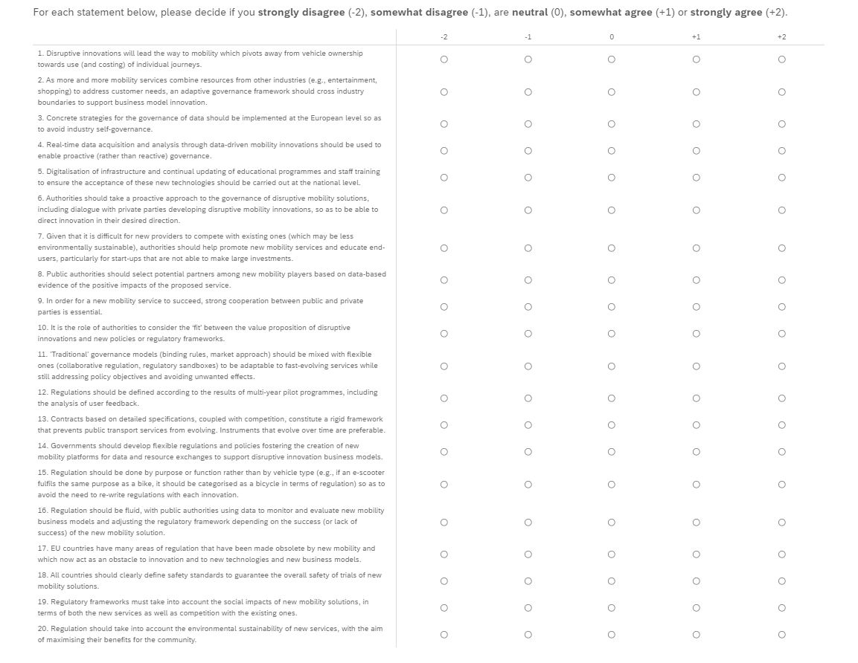

Setting priorities as we move forward
- During the course of our project, we (with input from you, our expert stakeholders) have identified 23 challenges to the regulation and governance of new mobility. We would like you to help us prioritise them.
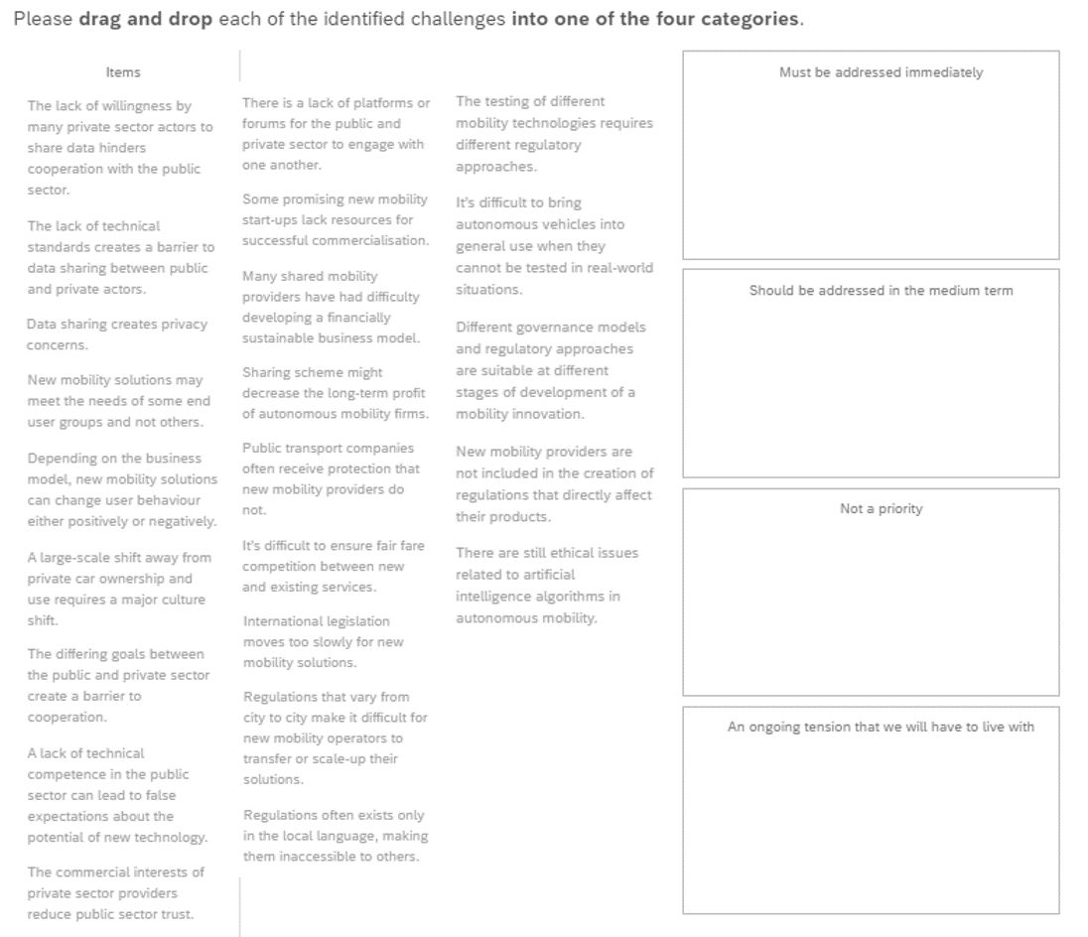

Covid-19 and the governance of new mobility
This next 3 questions are not mandatory but if you have a few extra minutes, we'd be grateful for your input. Otherwise, feel free to skip to the end - with our thanks for getting this far.
GECKO is working on an academic paper looking at the effects Covid-19 may have on the governance of new mobility solutions. We're trying to understand how governance changes brought on by the pandemic may (directly or indirectly) lead to changes in the way new mobility is governed.

- What governance responses to COVID-19 have affected the disruptive mobility innovations that you are familiar with and how? (please provide 1-3 examples) (e.g., reallocations of urban space has led to more people using bike sharing, financial subsidy of service X has disadvantaged service Y, free car parking in the city centre has discouraged the use of shared mobility...)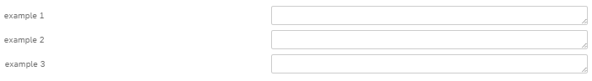

- Referring to your example(s) above, do you think the effect on new mobility will be temporary (ending with the pandemic) or permanent? 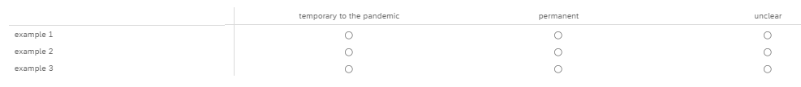

- How do you think the pandemic will change the way disruptive mobility is governed? (e.g., more/less collaboration, more/fewer data-informed decisions, faster/slower decision making...)

ANNEX 5: GECKO 2040 VISION
Hand-out provided in advance to stakeholders in the Looking Ahead to 2040 sessions.
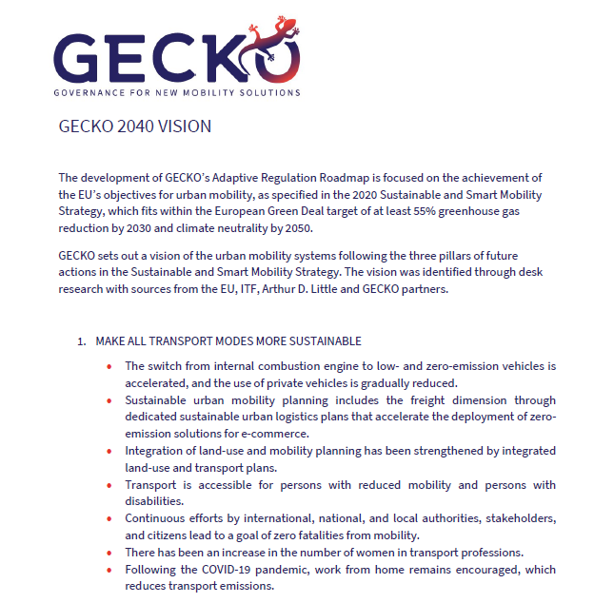
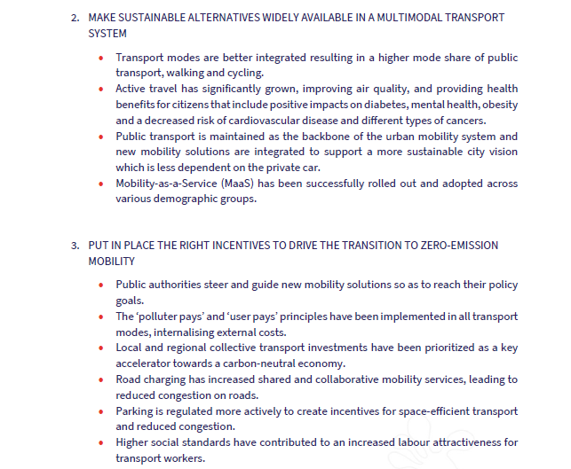

The consortium of GECKO consists of 10 partners with multidisciplinary and complementary competencies. This includes leading universities, networks and industry sector specialists.
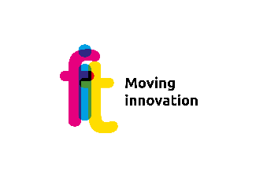
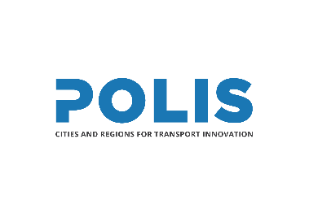
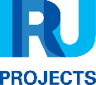
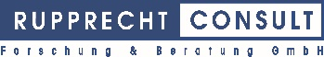
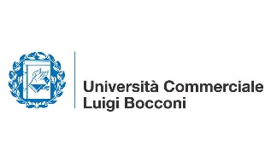
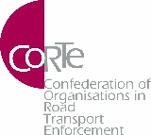
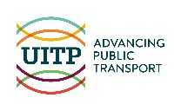

Contact:
Stakeholder Engagement Coordinator: Bonnie Fenton, Rupprecht Consult
Tel. +49-221-60 60 55 27
E-mail: b.fenton@rupprecht-consult.eu
Project Coordinator: Yannick Bousse, UITP
Tel. +32-2-788 01 25
E-mail: yannick.bousse@uitp.org

@H2020GECKO
#H2020GECKO https://www.linkedin.com/groups/8744013/
For further information please visit www.H2020-gecko.eu

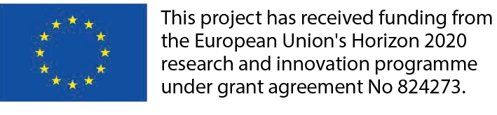
The sole responsibility for the content of this document lies with the authors. It does not necessarily reflect the opinion of the European Union. Neither the INEA nor the European Commission are responsible for any use that may be made of the information contained therein.

